**World Quant University**

**Professor: Steven Stelk**

**Risk Management**

Nikolas Lippmann Pareschi - [nikolaslippmann@gmail.com](mailto:nikolaslippmann@gmail.com)

**Project 1: Monte Carlo for Risk Estimation**

**I.**           Download data for last 5 years for all the 30 stocks of the Dow Jones Industrial Average (ignore survivorship bias, and unless you have access to a point-in-time database, simply download the data for the current set of DJIA index constituents.

**II.**         Calculate the following set of KPIs for each of the stocks over the period under study

o Average Monthly Return on a Positive Month   
o Average Monthly Return on a Negative Month   
o Probability of a Positive Month

I downloaded the XLS file provided in the forum. The part of the KPI was done using the code provided by the Professor in the Piazza forum. I adapted the downloaded data to compute another column called portfolio. In that way we could compute the KPIs metrics also for the portfolio.

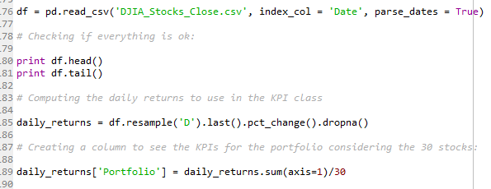

This is the classe used to compute the KPIs:

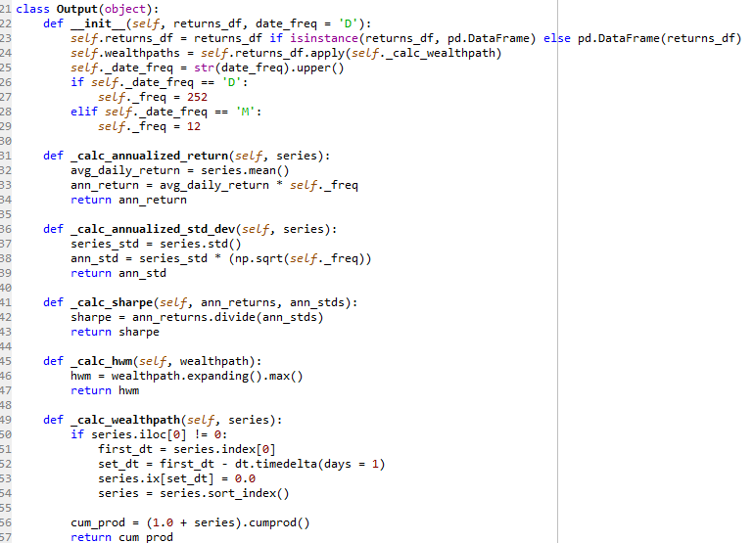

The

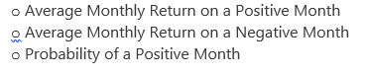

were calculated here:

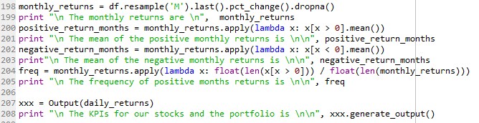

Results:

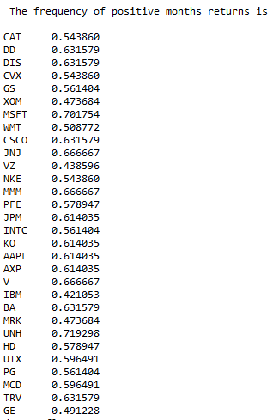 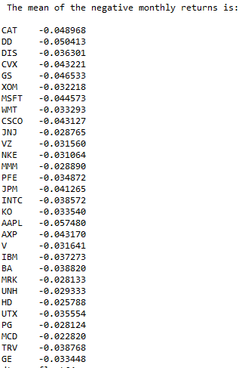

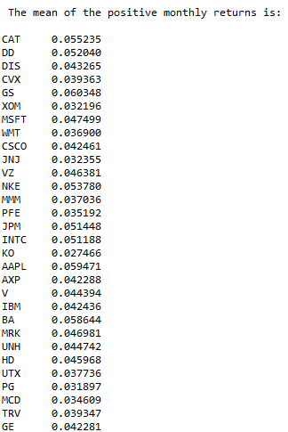 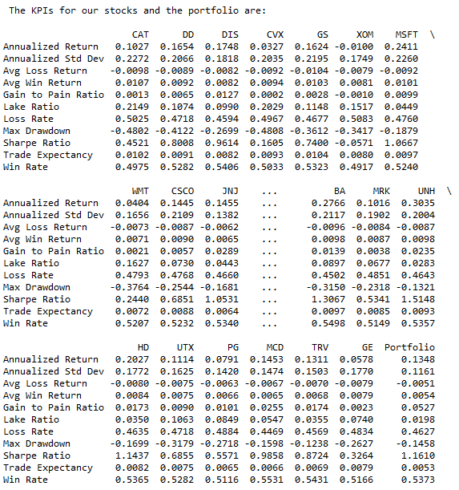

**I.**           Using the Ballpark estimates obtained from historical results, perform a Monte Carlo

Simulation using the following parameters o Consider a random selection of stocks from the 30 available in the DJIA.

o   Vary portfolio size between 15 to stocks in step sizes of 1

o   For simplicity, consider equal weighted portfolios with entire amount distributed and invested upfront (no adding up of positions once you are in the trade)

o   Consider simulation period of 60 months. Simulate each successive months returns based on probability and return values that are based on/similar to the historical return and probability values calculated in Step 2

* For each portfolio, simulate through the 60 steps (5 years of walk forward Monte Carlo) for 100 times. Given that we have 6 possible portfolio size combinations; this would give us 600 different outcomes in total

I used this function to compute the montecarlo simulation. The variables were defined as instructed:

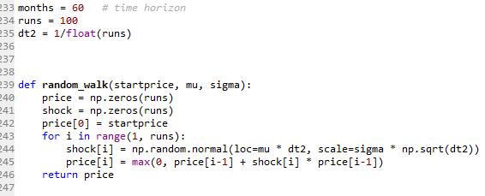

Nevertheless the assignment asked us to do the montecarlo simulations considering 6 portfolio size combinations, we did that in this loop:

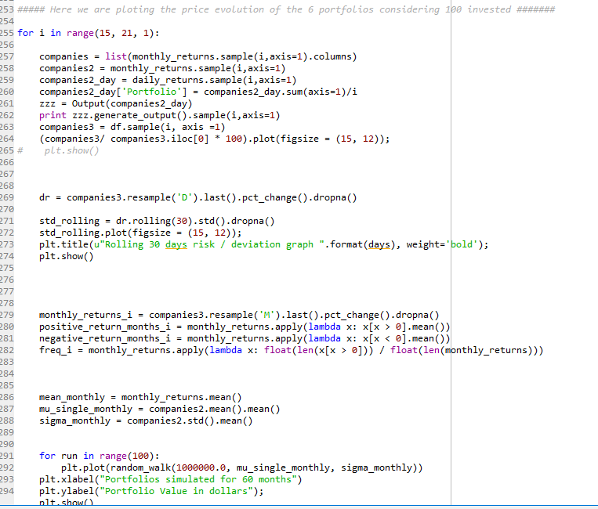

**II.**         Graphically represent the risk and return profiles of each of 600 simulations in two separate plots – one of Risk and another for the cumulative portfolio growth

Result for one randomly chosen portfolio:

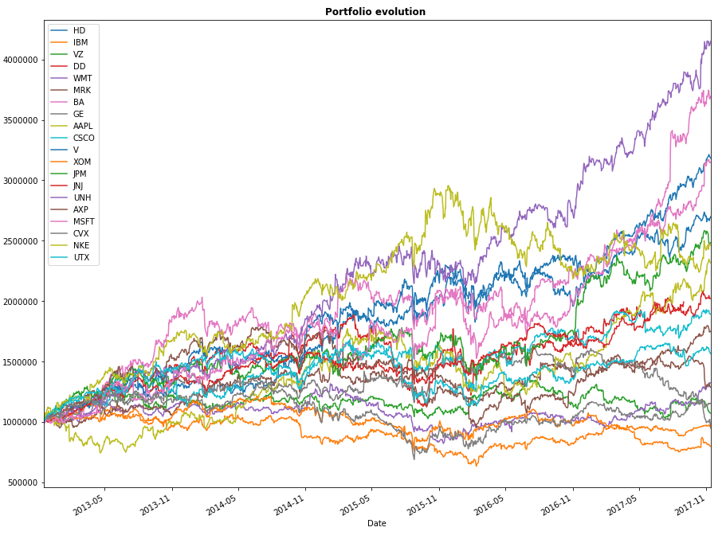

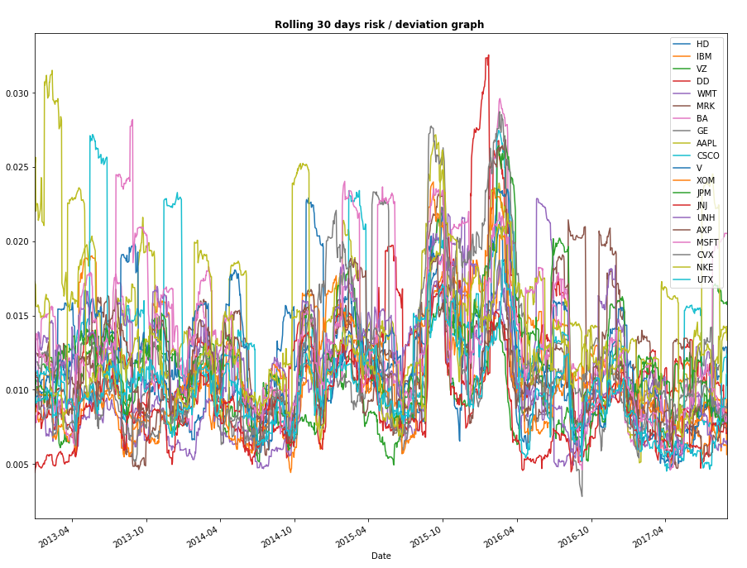

Results for the Montecarlo simulation:

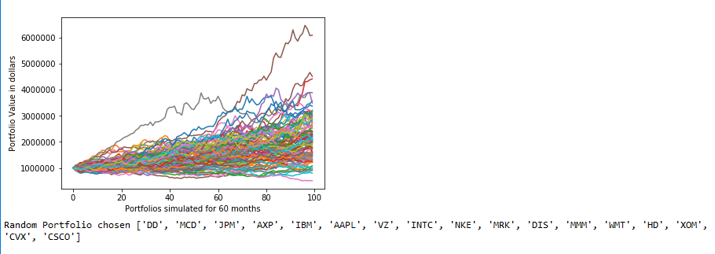

**III.**       Based on the results of the simulation, calculate measures of the mean portfolio returns, the overall variance of portfolio returns, maximum drawdown and the risk of ruin

The KPIs were computed using a new column called portfolio inside the loop, so we will have a portfolio for each randomly selected portfolio.

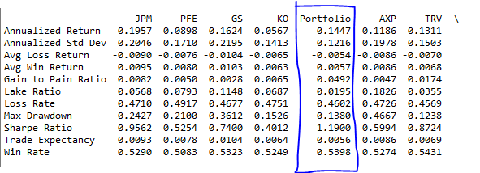

The metrics were computed also inside the first loop (nested loop):

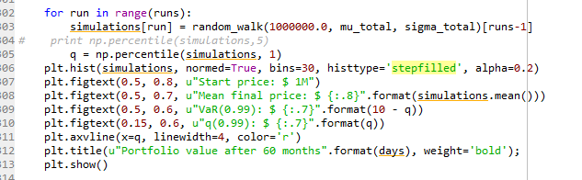

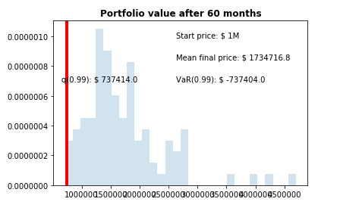

As one can see the risk of ruin is below 1%, considering that after 60 months a 1% VAR was above $ 737.404

**IV.**        Rerun the same simulations again, this time deliberately adding one two-day consecutive downwards price shock of 10% total anytime between the 10-50th step. Redo steps IV & V for the new set of simulation results

We did the same but this time considering price shocks as requested:

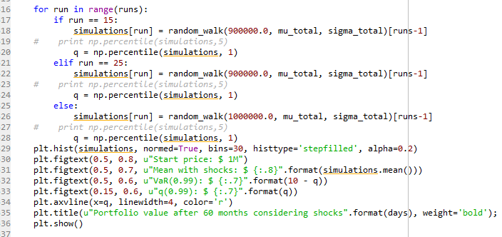

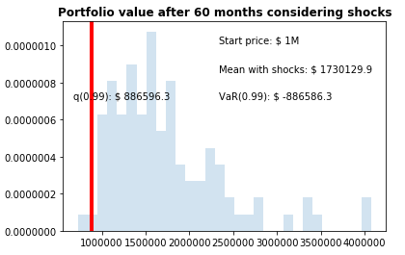

Considering the shock the 1% VAR got very high, but still below the initial capital of 1 million. The risk of ruin is not neglectable.

**Analysis**:

•        Given the dimensions of the study, how likely is the trader to reach her goal of 25% CAGR from a portfolio based on solely DJIA stocks?

•        What the risks she is exposing herself to by following her investment strategy?

•        Does such an investment strategy auger a favorable risk-return profile? How does the strategy stand up against downwards price shocks?

Considering all the randomly chosen portfolio scenarios never the CAGR was above 25%. With some montecarlo simulation it happen, but it was a rare occurrence.

If we only look at the drawdown that happened we can think the risks are not high. But considering the VAR 1% approach and the montecarlo simulations we see that it is possible that she will experience huge drawdowns.

The strategy seems to not break with the shocks, but it can get really tough.